|  |
| --- |
| Qatar National Library |
| Share point Permissions |
| Permission Groups settings for new Share point site |
| **7/28/2013** |
|  |
|  |

|  |
| --- |
|  |

This document summaries all the permission groups and their members for the new QNL Share point site. All the folder permission are based off these groups.

Table of Contents

Screen shot of Permission groups 2

QNL_SITEADMIN 3

QNL_SMAN 3

QNL_ADMF 4

QNL_ADMF_COMM 4

QNL_ADMF_FINANCE 4

QNL_ADMF_HR 4

QNL_ADMF_PROC 4

QNL_IT 5

QNL_IT_DS 5

QNL_IT_LSS 5

QNL_IT_WS 5

QNL_PS 6

QNL_PS_CS 6

QNL_PS_RLS 6

QNL_SPEC 7

QNL_SPEC_GC 7

QNL_SPEC_PSH 7

QN_TS 8

QNL_TS_AQ 8

QNL_TS_ACS 8

QNL_TS_CT 8

# Screen shot of Permission groups

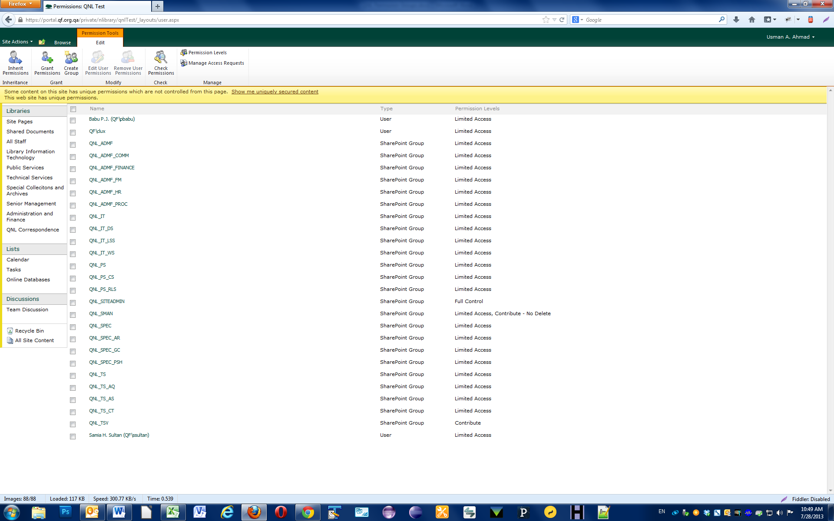

# QNL_SITEADMIN

Share point Site Administrators

**Members**

Usman Ahmad

Vikrama A. Ramaraja

# QNL_SMAN

Senior Management

**Members**

Dr. Claudia Lux

Samia Sultan

Babu P.J.

# QNL_ADMF

Administration and Finance (Head Only)

**Members**

Mr. Saadi Al Said

## QNL_ADMF_COMM

Communications Department

**Members**

Gihan Baraka

## QNL_ADMF_FINANCE

Finance Department

**Members**

Rowena Grenete

## QNL_ADMF_HR

Human Resources

**Members**

Mohammed H. Al Marri

## QNL_ADMF_PROC

Procurement Department

**Members**

# QNL_IT

Information Technology (Head Only) – AD and Head

**Members**

Krishna RoyChowdhury

## QNL_IT_DS

Digitization Services Department

**Members**

Vikrama Ramaraja

Sreenivasulu Dugginaboyina

Nooh Mohammed

Hamad Al Shamari

## QNL_IT_LSS

Library Systems team

**Members**

Vivek Yadava

Amr El Masry

## QNL_IT_WS

Web Services team

**Members**

Usman Ahmad

# QNL_PS

Public Services Department (Head Only)

**Members**

Allan Groen

## QNL_PS_CS

Children Services department

**Members**

Carol Mitchell

## QNL_PS_RLS

Reference Library Services Department

**Members**

Lisa Reynolds

Jooza Al Marri

Christine Afinidad

# QNL_SPEC

Special Collections Department (Head Only) – and Archives

**Members**

## QNL_SPEC_GC

Gulf Collection

**Members**

## QNL_SPEC_PSH

Partnership Services Department

**Members**

# QN_TS

Technical services Department (Head Only)

**Members**

Rex Steiner

## QNL_TS_AQ

Acquisitions team

**Members**

## QNL_TS_ACS

Access Services

**Members**

## QNL_TS_CT

Cataloging team

**Members**